# Introduction to Mixverse

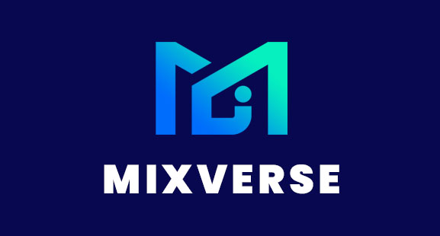

We are about to enter a whole new era - the Metaverse. This is the Web 3.0 stage of the Internet, representing the information revolution into the holographic era.

At the beginning of the metaverse era, due to incomplete infrastructure and unified standards, each domain metaverse was independent and not connected to each other. Therefore, a "local area network" metaverse was formed.

As technology continues to evolve, people are spending more and more time on VR/AR. In the next three to five years, VR and AR will be integrated and gradually replace mobile phones. The final form is smart glasses. Because it is inherently portable and brings new ways of interaction and sensory experience. It can allow people to enter the metaverse era completely.

**In 2025, it is expected that there will be one billion VR/AR devices on people's heads.**

**Vision**

Mixverse was born with the mission to provide users with maximum experience and participation in the virtual world. At the same time, we want to break the barriers and unify the standards to connect each metaverse to become the whole universe, so that users can enjoy each metaverse world.

The Mixverse is not an ordinary metaverse, nor is it an ordinary technological fusion, but the genesis of a new era in which the physical world merges with the virtual world, and carbon-based life merges with silicon-based life.

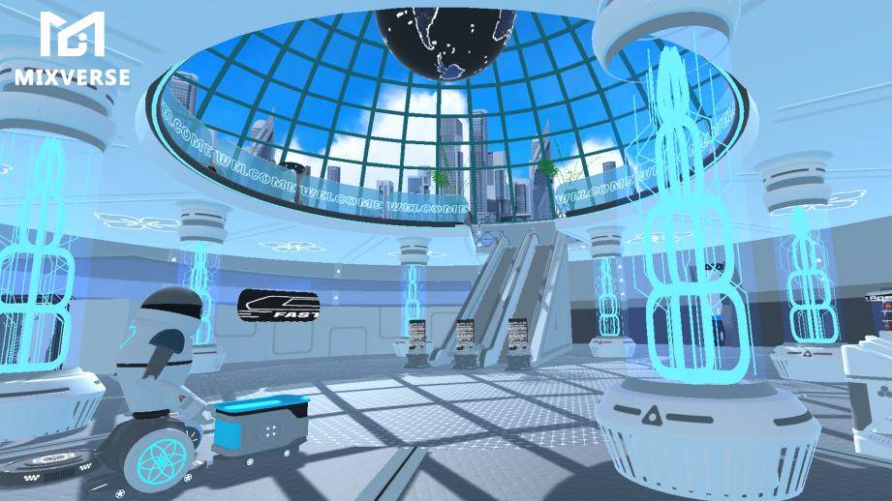

**What is Mixverse?**

**MixVerse is a Web 3.0 open system for VR/AR metaverse.**

**MixVerse provides MixSupport, a modular tool for building metaverse, and offers a full range of ecological synergies.**

Among them, Mixverse's main metaverse is an advanced eco-based metaverse that uses the decentralized blockchain technology of the Mixverse ecosystem as the underlying framework technology for world-building and the spirit of creation.

Unlike other metaverse projects, the competitiveness of Mixverse main metaverse lies in the fact that users in the physical world can enter the world of Mixverse main metaverse from various smart device terminals including VR/AR, PC, smartphones, etc., and perform various social behaviors such as living, working, socializing, business and gaming here, and interoperate with other metaverse in the Mixverse ecology.

Assets with value and ownership, such as users' land, property, Avatar, mounts, pets and other NFT assets, will be on the chain to ensure the scarcity, security and authenticity of the assets.

**Game Mechanics**

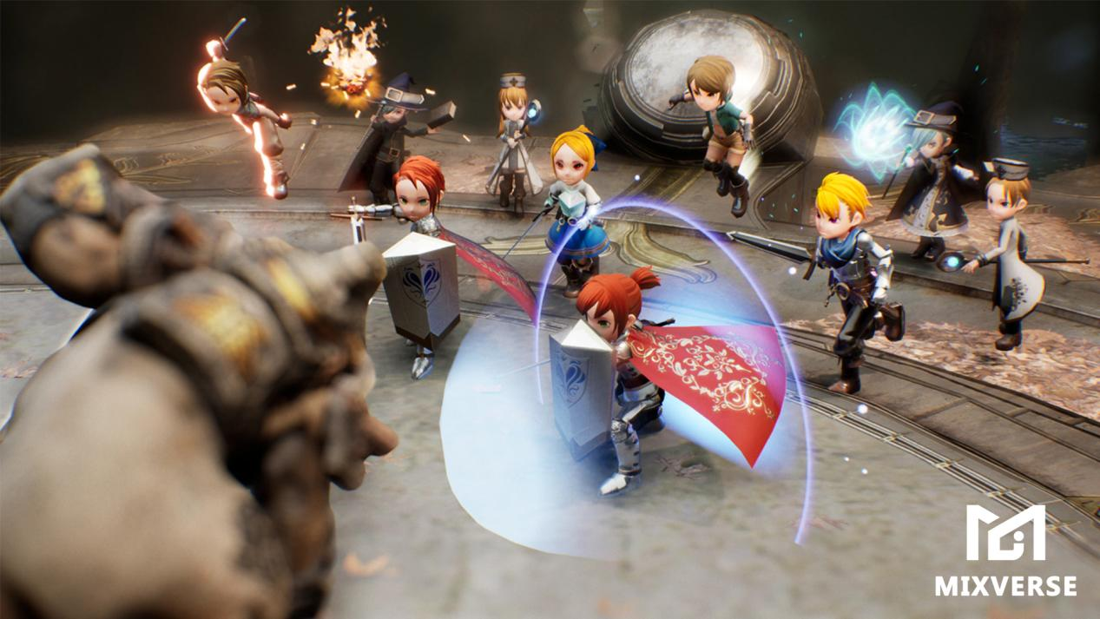

Mixverse offers users a wide variety of games that provide a pleasant and satisfying experience while also reaping MIX rewards. For example, RPG games, sandbox games, where users can also earn revenue by mining the land with NFT miners, and increase the efficiency of mining if they hire miners.

**Self-construction mode:** Users need dwellings to recover stamina to participate in various activities. Dwellings can be decorated and upgraded through NFT to improve recovery efficiency. Users can place, synthesize and build on the land through NFT to build a user co-constructed universe space.

**Business raising mode:** Users can engage in business activities on the land through NFT props to get the corresponding pay. This includes selling game props, NFT assets, providing stamina recovery services, providing toys such as social venues, and also participating in business activities by working part-time, building their own IP brand, etc. Employing workers can even increase revenue output.

**Social mode:** Users can participate in KTV and bars to socialize, or they can perform activities on apps with separate functions to reach specific goals.

**Social activity mode**: Just like the real world, people organize themselves into various social groups in Mixverse to discuss, supervise, and work together on specific tasks. Ultimately the DAO achieves by elections and leads the ecology forward.

**World PVP & GVG** : Every user has the opportunity to go to World PVP & GVG by improving their strength, building guilds, and having the chance to get epic NFT and token earnings. Various competitive events may be combined with epic quests, or released by DAO and major gaming organizations.

**Epic Mission**: In Mixverse, there will be a special Genesis Narrative Mainline---Epic Mission, posted by the project, where users can get the Genesis experience and revenue in return. In each metaverse within the ecosystem, users can also post missions and rewards to get others to participate.

**In short, here you can do what you want to do in the physical world but can't, and give better feedback to you in the physical world.**

**Developer**

Mixverse provides users with an application-level development tool, *MixEditor*. It allows developers and UGC enthusiasts to enter the main metaverse and build their own games, business and other application scenarios, and get MIX and Chaos rewards from them. Users can independently issue Tokens to integrate into the entire main metaverse economic cycle and even the Mixverse Ecology.

**About Mixverse Ecology**

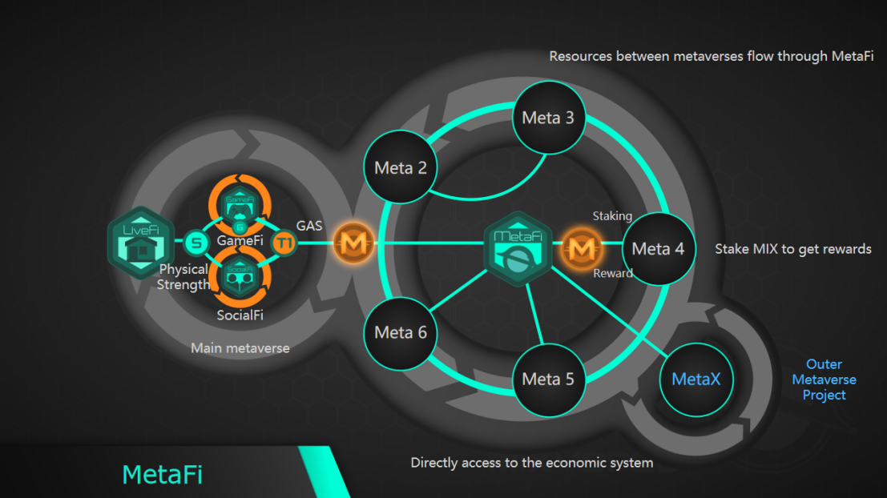

**MixSupport**

Mixverse provides users with VR/AR metaverse 3.0 solutions from devices, content to ecology, as well as providing full process support from universe creation to user autonomy.

Create metaverse with custom art style and game rules through powerful world editor MixEditor. We will generate Land, Token, NFT and customized App later.

Specify the ground rules of the universe by configuring the various levels of ecology within the metaverse. Access or create your own applications, and define and create activities for them.

Mixverse provides an AI interface to nurture AI to become pets, mounts, NPC, and even Avatars.

**MixSteam**

MixSteam reaches users and end devices across the whole Mixverse Ecosystem and is a cross-metaverse and cross-endpoint game/application distribution platform.

**MetaFi**

Behavior mining in metaverse. All behaviors of users in the Mixverse ecosystem (including cross-ecology partners) are weighted and quantified as activity to use as a reward criterion.

MetaFi is a microcosmic embodiment of a macroecology and can be connected to the behavior of the physical world. This is an important strategic layout for the future of Mixverse.